|  |
| --- |
| SWE-Project |
| Reversi |
| |  |  |  | | --- | --- | --- | | Bitbucket | Abdelgawad | abdelgawad@BIT | | Trello | Abdelgawad | abdelgawad@TRELLO | |

|  |  |  |  |  |
| --- | --- | --- | --- | --- |
| **ID** | **Name** | **Email** | **Dept/Grp** | **Mobile** |
| 20110281 | Mohamed Ahmed abd-algawad | Abdelgawad22@yahoo.com | CS_3 | 01112663844 |
| 20110335 | Mohamed Waleed Mohamed | max_max2394@yahoo.com | CS_3 | 01111533876 |
| 20110277 | Mohamed Ibrahim Mohamed | mibrahim070@gmail.com | CS_3 | 01117558353 |
| 20110432 | Ahmed Nasser Saleh | Ahmednasser1993@gmail.com | CS_4 | 01060185459 |

* *The work which has to be done in this step is done (100%), but respect to the whole project is 30%.*

**Trello & Bitbucket screenshots**

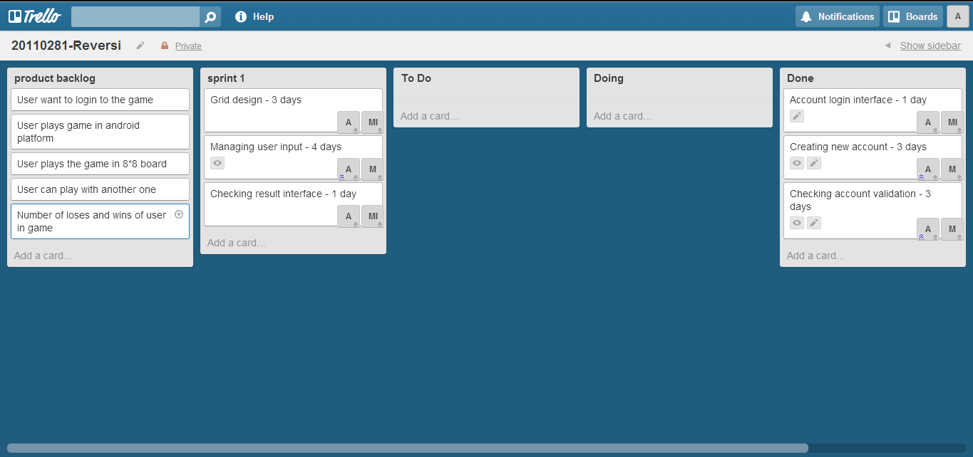

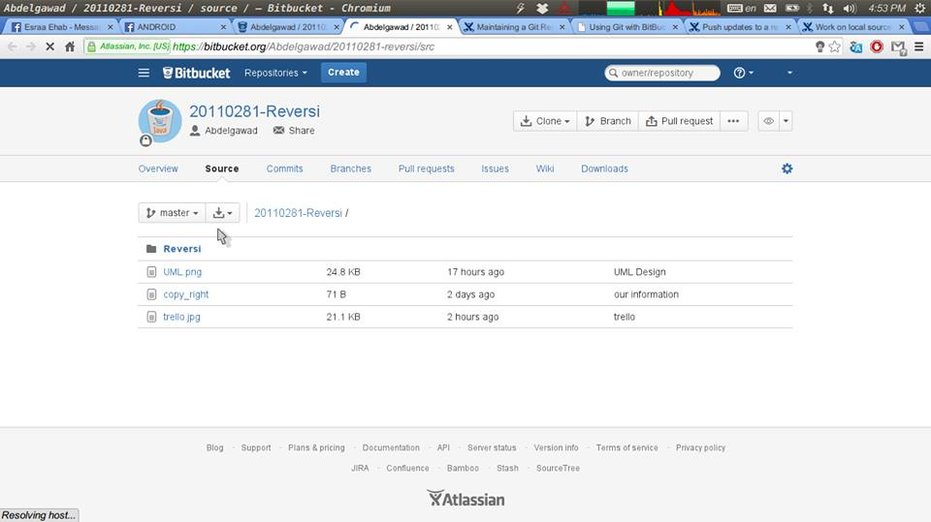

**UML**

